DELIVERY OF SPRINT 4

|  |  |
| --- | --- |
| **Date** | 14 November 2022 |
| **Team ID** | PNT2022TMID52668 |
| **Project Name** | Smart waste management system for metropolitan cities |

Node Red connections and the UI

1. **IBM Watson device connections:**

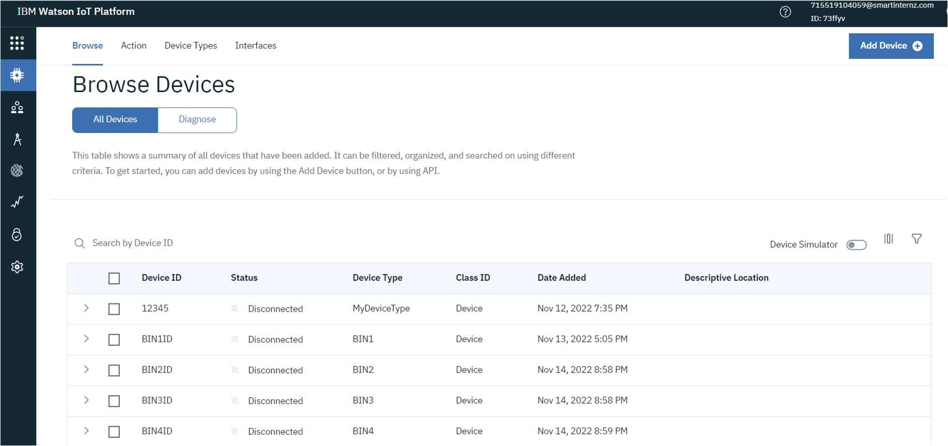

1. **Node-Red connections:**

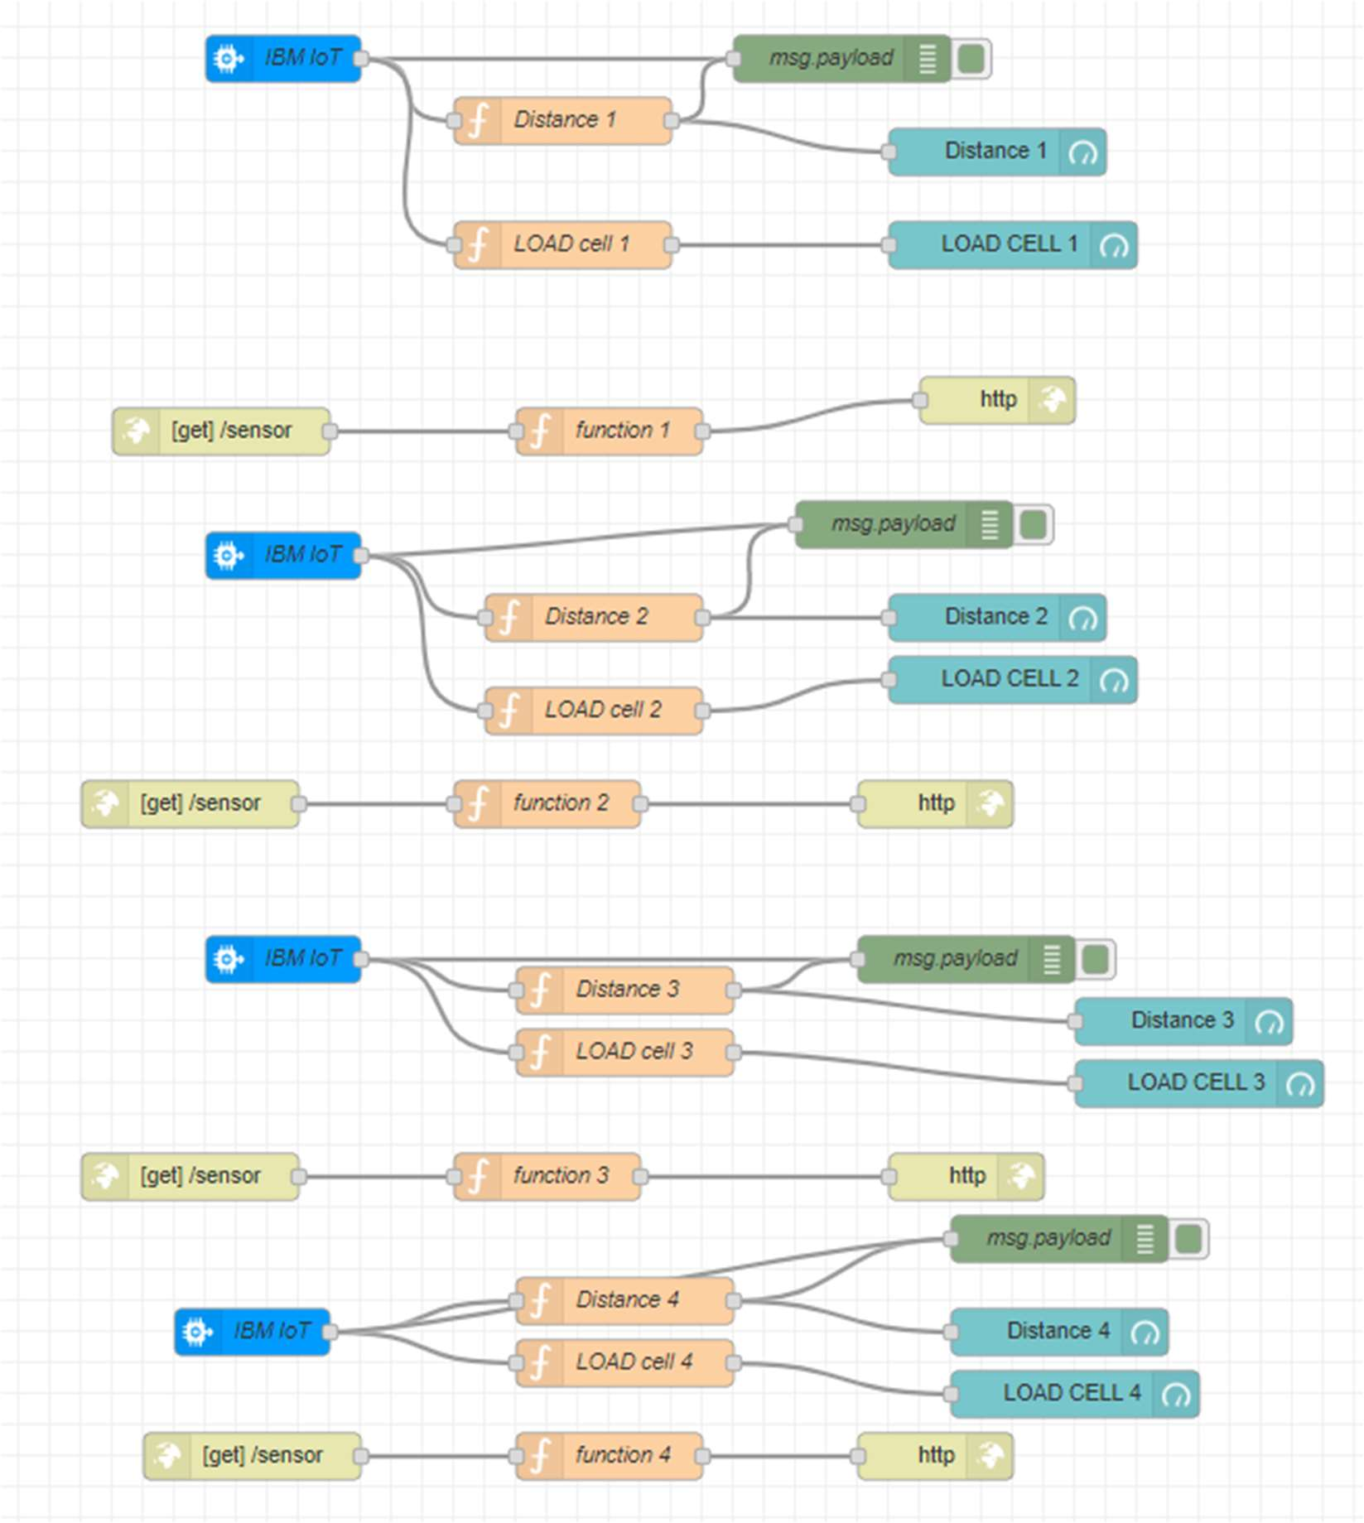

1. **The website – UI output displayed based on the python scripts execution:**

